**KPI’s:**

**Total Loan Applications**

Bank Loan Report [ SQL ]

KPI’s: -

select count(id)as Total_Loan_Aplications

from bank_loan_data



**PMTD Loan Applications**

select count(id)as PMTD_Total_Loan_Aplications

from bank_loan_data

where MONTH(issue date) = 11 and YEAR (issue date) =2021



**Total Funded Amount**

select sum (loan_amount) as Total_Funded_Amount

From bank_loan_data



**MTD Total Funded Amount**

select sum (loan_amount) as MTD_Total_Funded_Amount

From bank_loan_data

where month(issue_date) =12 and year(issue_date) =2021



**PMTD Total Funded Amount**

select sum (loan_amount) as PMTD_Total_Funded_Amount

From bank_loan_data

where month(issue_date) =11 and year(issue_date) =2021



**Total Amount Received**

select sum(total_payment) AS Total_Amount_received

From bank_loan_data



**MTD Total Amount Received**

select sum(total_payment) AS MTD_Total_Amount_received

From bank_loan_data

Where MONTH(issue_date) = 12 and YEAR (issue_date) = 2021



**PMTD Total Amount Received**

select sum(total_payment) AS PMTD_Total_Amount_received

From bank_loan_data

Where MONTH(issue_date) = 11 and YEAR (issue_date) = 2021



**Average Interest Rate**

select round (Avg(int_rate) *100,2) As Avg_Intrest_Rate

From bank_loan_data



**MTD Average Interest**

select round (Avg(int_rate) *100,2) As MTD_Avg_Intrest_Rate

From bank_loan_data

Where MONTH(issue_date) =12 and YEAR (issue_date) =2021



**PMTD Average Interest**

select round (Avg(int_rate) *100,2) As PMTD_Avg_Intrest_Rate

From bank_loan_data

Where MONTH(issue_date) =11 and YEAR (issue_date) =2021



**Avg DTI**

Select round (avg(dti)*100,2) As Avg_DTI

From bank_loan_data



**MTD Avg DTI**

Select round (avg(dti)*100,2) As MTD_Avg_DTI

From bank_loan_data

where MONTH (issue_date) = 12 and YEAR (issue_date) = 2021



**PMTD Avg DTI**

Select round (avg(dti)*100,2) As PMTD_Avg_DTI

From bank_loan_data

where MONTH (issue_date) = 11 and YEAR (issue_date) = 2021



**GOOD LOAN ISSUED**

**Good Loan Percentage**

select (COUNT(case when loan_status = 'Fully Paid' or loan_status = 'current' then id end)*100)

/

count(id) as Good_loan_Percentage

From bank_loan_data



**Good Loan Applications**

select count (id) As Good_loan_applications

from bank_loan_data

where loan_status ='fully paid' or loan_status='current'



**Good Loan Funded Amount**

select sum(loan_amount) As Good_loan_Funded_amount

from bank_loan_data

where loan_status = 'fully paid' or loan_status = 'current'



**Good Loan Amount Received**

select sum(total_payment)As Good_loan_Reveive_amount

from bank_loan_data

where loan_status = 'fully paid' or loan_status = 'current'



**BAD LOAN ISSUED**

**Bad Loan Percentage**

Select (count(case when loan_status = 'charged off' then id end)*100)

/

count(id) as bad_loan_percentage

from bank_loan_data



**Bad Loan Applications**

select count(id) as bad_loan_applications

from bank_loan_data

where loan_status = 'charged off'



**Bad Loan Funded Amount**

select sum(loan_amount) as bad_loan_funnded_amount

from bank_loan_data

where loan_status = 'charged off'



**Bad Loan Amount Received**

select sum(Total_payment)as bad_loan_received_amount

from bank_loan_data

where loan_status = 'charged off'



**LOAN STATUS**

select

loan_status,

count(id) as Total_loan_applications,

sum(total_payment) as Total_amount_received,

sum(loan_amount) as Total_funded_amount,

avg(int_rate*100) as Intrest_rate,

avg(dti*100) as DTI

from bank_loan_data

group by loan_status

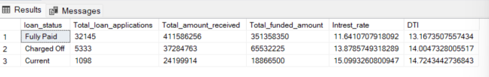

1. **BANK LOAN REPORT | OVERVIEW**

select

month (issue_date) as Month_Number,

datename (month,issue_date)as Month_Name,

count(id) as Total_loan_applications,

sum (loan_amount) as Total_funded_amount ,

sum (total_payment) as Total_received_amount

From bank_loan_data

group by month (issue_date),datename(month,issue_date)

order by month(issue_date)

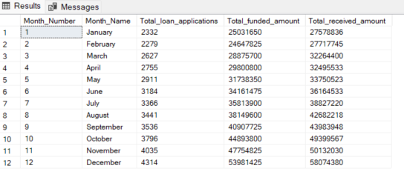

select

address_state,

count(id) as Total_loan_applications,

sum (loan_amount) as Total_funded_amount ,

sum (total_payment) as Total_received_amount

From bank_loan_data

group by address_state

order by sum(loan_amount) desc

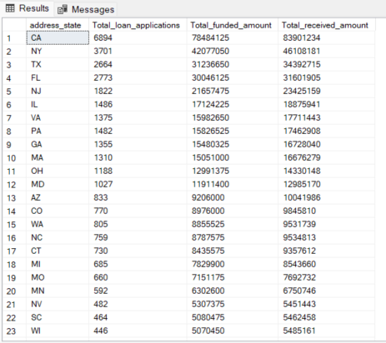

select

term,

count(id) as Total_loan_applications,

sum (loan_amount) as Total_funded_amount ,

sum (total_payment) as Total_received_amount

From bank_loan_data

group by term

order by term

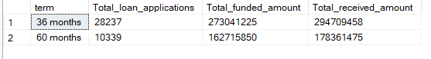

select

emp_length,

count(id) as Total_loan_applications,

sum (loan_amount) as Total_funded_amount ,

sum (total_payment) as Total_received_amount

From bank_loan_data

group by emp_length

order by emp_length

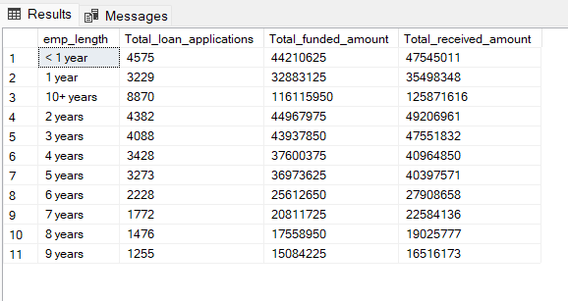

select

purpose,

count(id) as Total_loan_applications,

sum (loan_amount) as Total_funded_amount ,

sum (total_payment) as Total_received_amount

From bank_loan_data

group by purpose

order by count(id) desc

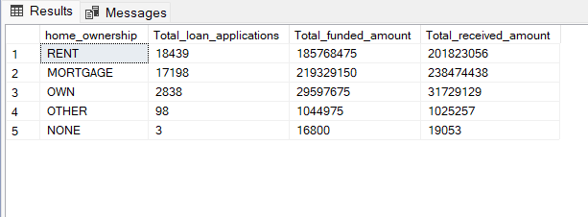

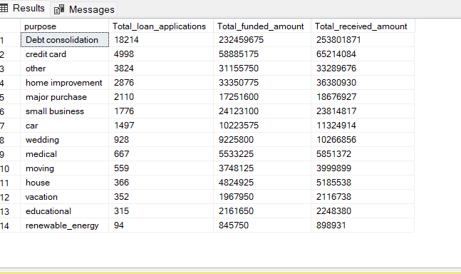

select

home_ownership,

count(id) as Total_loan_applications,

sum (loan_amount) as Total_funded_amount ,

sum (total_payment) as Total_received_amount

From bank_loan_data

group by home_ownership

order by count(id) desc